**Linear and Binary search algorithm**

Linear:

Linear search is a simple search algorithm that checks every record until it finds the target value. Linear search can be done on a linked list, which allows for faster insertion and deletion than an array.

2. A Linear Search is the most basic type of search algorithm. A Linear Search sequentially moves through your collection (or data structure) looking for a matching value. In other words, it looks down a list, one item at a time, without jumping.

Here is an image of linear search

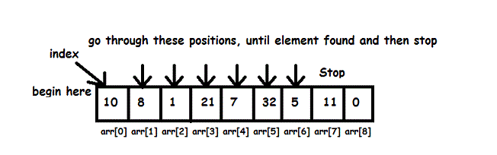

* Works by checking each element to see if it matches the target.
* repeats until a match is found or the whole list has been checked..
* It’s a simple brute force algorithm that checks a list looking for a match.
* The linear search algorithm requires a target.
* Not as efficient as binary.
* Has to check every single element.

Binary:

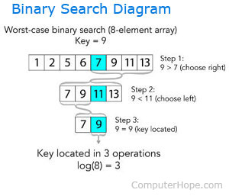

In computer, binary search, also known as half-interval search, logarithmic search or binary chop is a search algorithm that finds the position of a target value within a sorted array Binary search compares the target value to the middle element of the array.

If they are not equal, the half in which the target cannot lie is eliminated and the search continues on the remaining half, again taking the middle element to compare to the target value, and repeating this until the target value is found. If the search ends with the remaining half being empty, the target is not in the array.

* Slightly more complicated but a lot more efficient than linear search.
* It continually divides a list by two, eliminating the part of the list that cannot have your item in it.
* The list must be fully sorted/ordered first to eliminate halves because its split into halves like binary its in 2 different parts.
* Can instantly half elements that are inadequate to the results.
* Binary search is faster except for small arrays. However, the array must be sorted first to be able to apply binary search.